GGR472 Developing Web Maps

Group Project Proposal

Professor Smith

Anna Hein, Alex Taylor, Kelly Hsu

February 16, 2024

**Emphasizing Active Modes of Transportation with the Toronto District School Board**

**Objectives**

Our group project will be part of UofT’s Sandbox Initiative which will work in partnership with the Toronto District School Board (TDSB) to encourage students to commute via active transportation. Our group will work with Sam Perry from the TDSB and Christine Ovcaric from the University of Toronto’s Department of Experiential Learning & Outreach Support. Active transportation is a popular discourse in the local-level climate change debate, as it is important for reducing carbon dioxide emissions and congestion. Other positive impacts of using active modes of travel include increased physical activity and health and increased social interaction.

Our group will create a web map that provides information regarding opportunities for active modes of transportation to schools to key stakeholders, including parents and students. Our map will aim to allow the stakeholders to explore various options and make informed decisions about their journey to school. Since there are many schools within the TDSB, one option could be to include an overview map of all the TDSB schools, similar to the one shown in Figure 1. Another option would be to focus on a singular school and make our web map scaleable for future projects that might include multiple schools.

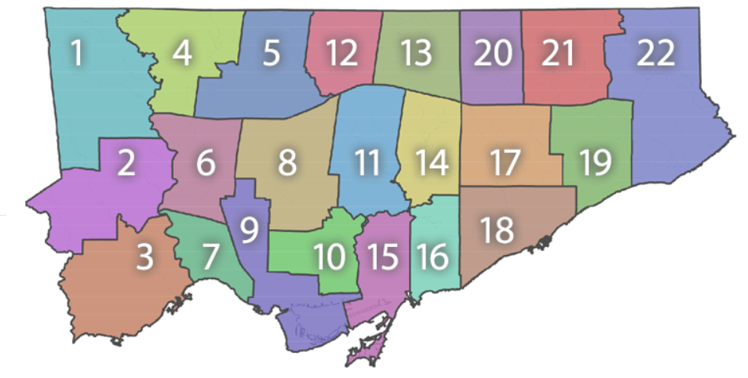

**Figure 1:** Map of TDSB school districts

(<https://www.tdsb.on.ca/Find-your/School/PDF-Map>)

Because our group is working with an external party, communication is crucial for our project. And, as of currently, we have not had an initial meeting to decide our specific focus or study area. So, the factors described in our proposal are subject to change throughout the project's timeline.

**Data**

Our group plans to utilize open-sourced, public data to create our web map. This includes data from Toronto’s Open Data Portal, Toronto real-time weather and traffic data using APIs, and air quality data collected by the chemistry class last term (while this was only done for a single location, it may still be useful). Most of this data is going to be in tabular and some in vector format. We also have a network for all Toronto streets that we plan on using to calculate routes.

**Design and interactivity**

Points on our web page will represent TDSB schools. As users zoom in and out, the point size will decrease or increase, respectively (Figure 2). Once the user locates their school, the map will provide an overview of the school's information, including its address and name through a popup feature (Figure 3). In addition, our group is considering including potential walking school bus routes and stops, more specifically by identifying and readily displaying which roads have safe bike lanes and lower speed limits.

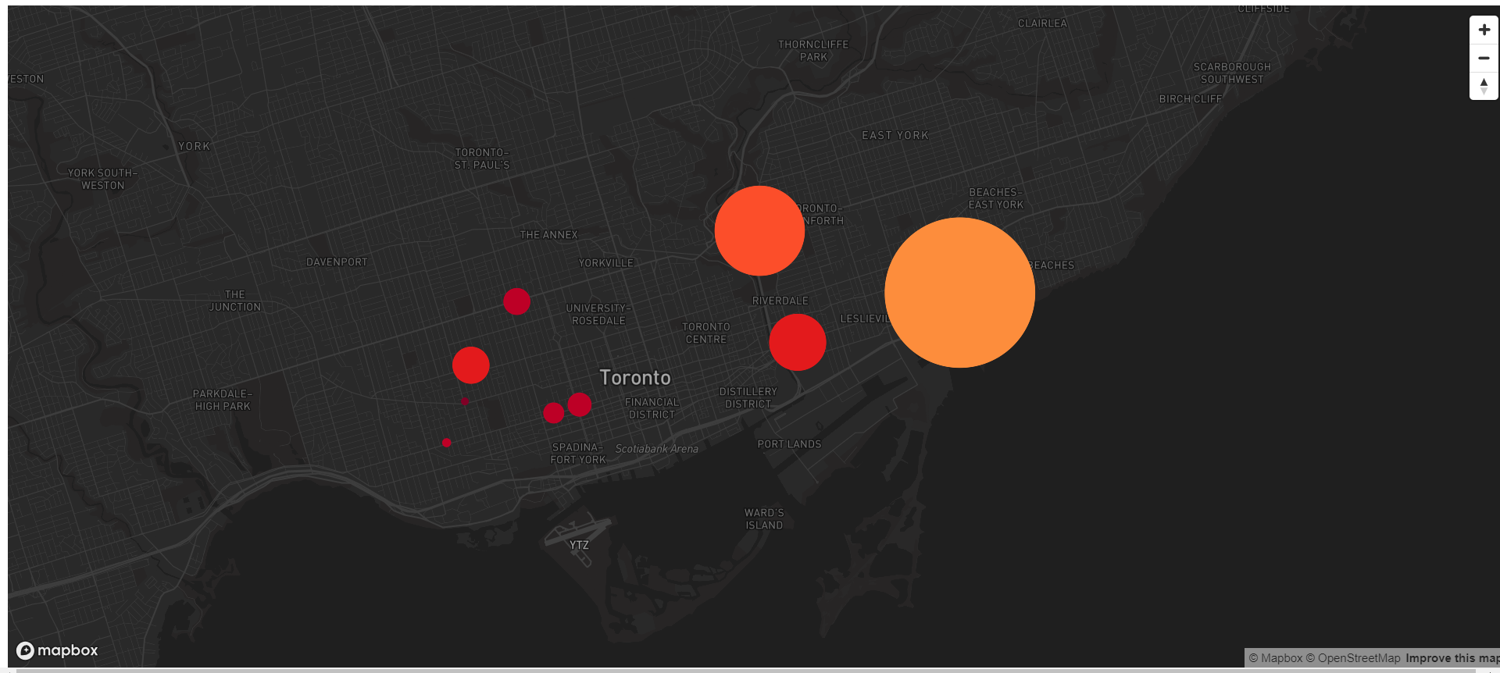

**Figure 2:** This is an example of a Mapbox map where points change size when the user zooms in and out to show a value's significance, similar to the TDSB map shown in Figure 1.

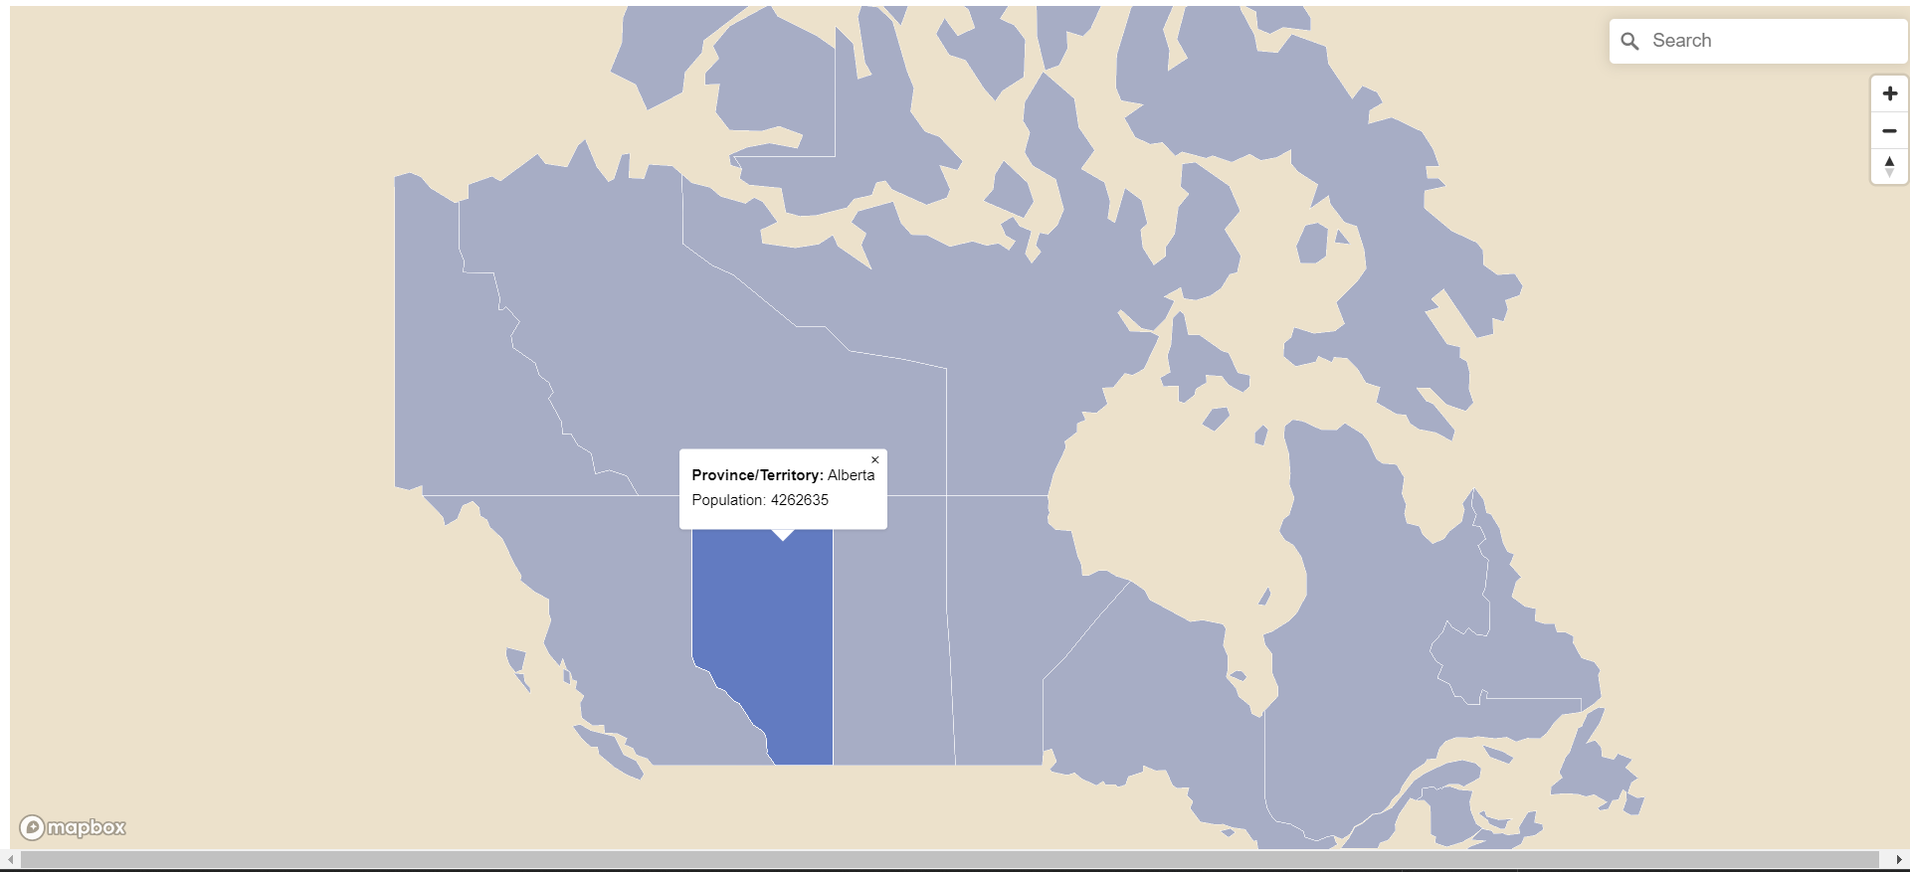

**Figure 3:** This is an example of a mapbox map where the user can click a geospatial feature and a description of the feature will pop up. Our project would use this example to highlight a school's information as well as road information, such as speed limit and bike lane safety information.

Some other potential features of user interactivity could include allowing users to map a route to a school. More specifically, our web map will include a geospatial analysis tool that allows users to measure distances between points for potential routes. Within this function, users can examine road speed limits and the availability and accessibility of bike lanes and sidewalks along the chosen route. There are open data sources regarding bike lanes and speed limits; however, our group has struggled to find sufficient data on sidewalks. Although we would like to include information about sidewalks, we are unsure if we will be able to find a good enough data source for it.

Stylistically, we expect to have a main splash page with the map. There will be a sidebar with various toggles and filters. A navbar will exist to guide the user to other pages, such as FAQ / How to Use, Rules to Know when Cycling, etc… We are also considering making two maps, one designed for children and the other for their parents. The main difference is that the child-oriented one would use more vivid colors and landmarks that they could recognize along their journey while the adult one would have more details to answer parents’ questions.

**Process**

There are three main portions to our map: the visual aspects and design of our website, the data processing and file structure, and the map interactivity. While no specific roles have been outlined yet, we think that Anna would be doing the first part, Kelly the second, and Alex the third. Each of these tasks can be largely worked on independently, though they all interact with one another. Thus, communication and regular use of GitHub will be crucial to ensure interoperability. Additionally, having multiple sets of eyes on a task is something that our group finds important, so we will be helping each other out throughout the coding process, giving us critical context on others’ work when we work on our sections.